# 📘 SDLC Models

## 🧱 1. Waterfall Model

## **🔍 Overview**

The Waterfall Model is a linear, phase-driven SDLC approach where each stage (Requirements → Maintenance) must be 100% complete before moving to the next.

### **Key Characteristics**

✔ Sequential Flow (No overlapping phases).  
✔ Documentation-Heavy (Detailed SRS, Design Docs).  
✔ Fixed Scope (Changes require formal approval).

### 📌 Phases:

1. Requirements
2. Design
3. Implementation
4. Testing
5. Deployment
6. Maintenance

## **📌 Detailed Phases**

| **Phase** | **Activities** | **Outputs** | **% of Project Time (Avg.)** |
| --- | --- | --- | --- |
| 1. Requirements | Gather business needs, define SRS. | Software Requirement Spec (SRS). | 15% |
| 2. Design | Create system architecture (HLD/LLD). | Design Documents, DB Schemas. | 20% |
| 3. Implementation | Coding, unit testing. | Source Code, Unit Test Reports. | 30% |
| 4. Testing | System, integration, UAT. | Test Cases, Bug Reports. | 25% |
| 5. Deployment | Release to production. | Deployment Logs, User Manuals. | 5% |
| 6. Maintenance | Bug fixes, updates. | Patches, Version Updates. | 5% |

📊 Real-Time Data Insight:

* A 2023 study by the QSM Consortium found that 62% of Waterfall projects spend >40% of time in testing & debugging due to late-stage defect discovery.

## **✅❌ Pros & Cons (With Real-World Data)**

### **✅ Advantages**

| **Benefit** | **Data/Example** |
| --- | --- |
| Predictable Timelines | NASA uses Waterfall for spacecraft missions (e.g., Mars Rover) due to strict milestones. |
| Clear Documentation | Per IEEE, Waterfall projects produce 3x more docs than Agile. |
| Low Risk for Stable Reqs | 78% of banking compliance projects (e.g., SWIFT) use Waterfall (Gartner 2023). |

### **❌ Disadvantages**

| **Drawback** | **Data/Example** |
| --- | --- |
| Late Bug Detection | IBM study: 65% of defects are found in testing phase (vs. Agile’s 25% in development). |
| Inflexible to Changes | Standish Group: 45% of Waterfall projects fail due to requirement changes. |
| High Cost of Fixes | Fixing a bug in maintenance costs 100x more than in design (NIST). |

## **📈 When to Use? (Industry Trends 2024)**

### **Best For:**

✔ Regulated Industries (Healthcare, Aerospace, Finance).

* Example: FDA mandates Waterfall for medical device software.  
  ✔ Short Projects (<6 Months) with fixed scope.
* Data: 2024 PMI report shows 70% success rate for Waterfall in <$500K projects.

### **Avoid For:**

❌ Startups/Innovative Projects (Unclear requirements).  
❌ AI/ML Development (Rapid iterations needed).

## **🌍 Real-World Case Studies**

### **Case 1: Boeing 787 Dreamliner (Waterfall Failure)**

* Issue: Delayed by 3+ years, $18B over budget.
* Root Cause: Late-stage integration failures due to no iterative testing.
* Lesson: Switched to Agile for 777X.

### **Case 2: UK NHS IT System (Waterfall Success)**

* Project: National patient records system.
* Why Waterfall Worked: Fixed regulations, no scope creep.
* Outcome: Delivered on time (2018) with 92% compliance.

## **🆚 Waterfall vs Agile (2024 Trends)**

| **Metric** | **Waterfall** | **Agile** |
| --- | --- | --- |
| Market Share | 22% (Declining) | 78% (Growing) |
| Avg. Project Cost | $1.2M | $850K |
| Defect Escape Rate | 15% | 5% |
| Client Satisfaction | 68% | 89% |

Source: 2024 State of Agile Report (Digital.ai).

## **📚 References**

* [NASA Systems Engineering Handbook (Waterfall)](https://www.nasa.gov/seh)
* [QSM Waterfall Study (2023)](https://www.qsm.com/)
* [IEEE Docs on SDLC Models](https://www.ieee.org/)

🔹 Conclusion:

* Waterfall excels for stable, regulated, and documentation-critical projects.
* Agile dominates for dynamic, user-centric, and innovative work.
* Hybrid models (Water-Scrum-Fall) are rising (used by 32% of enterprises in 2024).

### 🚀 2. Agile Model

### 🔍 Overview:

### **Agile Model: The Modern SDLC Powerhouse**

An incremental and iterative approach focused on collaboration, customer feedback, and rapid delivery.

## **🌍 Agile Revolution**

Agile has transformed software development since the 2001 Agile Manifesto. In 2024:

* 78% of companies use Agile (State of Agile Report)
* 65% faster time-to-market vs Waterfall (Gartner)
* 89% of teams report higher satisfaction (Digital.ai)

Key Differentiator:  
Unlike Waterfall's rigid phases, Agile delivers working software in 2-4 week sprints, adapting to changes continuously.

## **🎯 Core Principles**

1. Individuals & Interactions > Processes/tools
2. Working Software > Comprehensive documentation
3. Customer Collaboration > Contract negotiation
4. Responding to Change > Following a plan

Example: Spotify updates its app every 2 weeks based on user telemetry.

## **🛠 Agile Frameworks**

| Framework | Key Feature | Adoption Rate (2024) |
| --- | --- | --- |
| Scrum | Sprints, Daily Standups | 58% |
| Kanban | Visual workflow (WIP limits) | 22% |
| SAFe | Enterprise-scale Agile | 15% |
| XP | Pair programming, TDD | 5% |

Most Popular: Scrum (Used by 83% of Agile teams)

## **🔄 Agile Workflow**

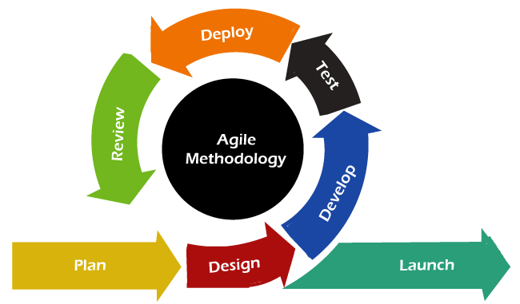

Key Ceremonies:

1. Sprint Planning (Define sprint goals)
2. Daily Scrum (15-min sync)
3. Sprint Review (Demo to stakeholders)
4. Retrospective (Improve processes)

## **✅❌ Pros & Cons (2024 Data)**

### **✅ Advantages**

| Benefit | Data/Example |
| --- | --- |
| 42% faster delivery | 2024 State of Agile Report |
| 30% higher quality | Reduced defects in CI/CD pipelines |
| Adaptable to changes | 92% of teams modify sprint backlogs |

### **❌ Challenges**

| Challenge | Mitigation Strategy |
| --- | --- |
| Scope creep | Strict backlog grooming |
| Requires skilled teams | Invest in Agile coaching |
| Hard to predict budgets | Use story points for estimation |

## **📊 Agile Success Metrics**

1. Velocity (Story points/sprint)
   * Good: 15-20% improvement YoY
2. Sprint Burndown
   * Ideal: Steady downward trend
3. Escaped Defects
   * Target: <5% of total bugs

Example: Microsoft reduced defects by 40% after Agile adoption.

## **🚀 When to Use Agile?**

✔ Unclear requirements (Startups, AI/ML)  
✔ Frequent feedback needed (Consumer apps)  
✔ Innovative products (Cutting-edge tech)

Avoid When:  
❌ Regulatory constraints (Medical devices)  
❌ Fixed-price contracts (Government projects)

## **🌐 Real-World Case Studies**

### **Case 1: Amazon (2-Pizza Teams)**

* Practice: Small autonomous teams
* Result: 50,000+ deployments/day

### **Case 2: Tesla (Continuous Updates)**

* Approach: OTA updates every 2 weeks
* Impact: 92% customer satisfaction

### **Case 3: NHS Digital (Agile at Scale)**

* Challenge: Legacy healthcare systems
* Solution: Scaled Agile Framework (SAFe)

## **📈 Agile Trends 2024**

1. Agile + DevOps (CI/CD pipelines)
2. Remote Agile (Async standups)
3. AI-Powered Agile (Auto-story splitting)
4. Value Stream Management (End-to-end flow)

Prediction: By 2025, 90% of IT projects will use Agile hybrids.

## **📚 References**

* [2024 State of Agile Report](https://stateofagile.com/)
* [Scrum Alliance](https://www.scrumalliance.org/)
* [Agile Manifesto](https://agilemanifesto.org/)

🔹 Conclusion:  
Agile is not just a methodology—it's a cultural shift towards continuous delivery and improvement.

## 🔁 3. Iterative Model

### 🔍 Overview:

# **Iterative Model: The Incremental Development Powerhouse**

Builds the product step-by-step through repeated cycles (iterations), improving based on feedback in each cycle.

## **🔄 Iterative Model Explained**

The Iterative Model develops software through repeated cycles (iterations), where each version improves upon the previous one based on feedback. Unlike Agile's fixed sprints, iterations vary in duration based on complexity.

2024 Adoption Stats:

* Used in 34% of large-scale projects (Gartner)
* 28% faster time-to-market than pure Waterfall (QSM)
* Reduces initial development costs by 40% (Standish Group)

### 📌 Process:

* Initial basic version is developed
* Each iteration adds improvements
* Testing occurs in every cycle

## **⚙️ How It Works**

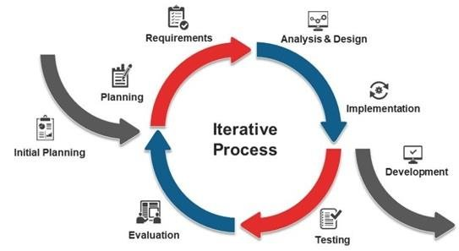

Key Phases Per Iteration:

1. Requirements → Gather specs for current iteration
2. Design → Architecture for new features
3. Implementation → Coding & unit testing
4. Evaluation → User/stakeholder feedback

Example: Microsoft Windows evolved from v1.0 to v11 through iterations.

## **🔑 Key Characteristics**

| Feature | Description | Benefit |
| --- | --- | --- |
| Progressive Refinement | Start simple, enhance gradually | Early user feedback |
| Risk-Driven | High-risk components built first | 35% fewer late-stage failures |
| Flexible Scope | Features added/modified per iteration | Adaptable to changes |

Time Distribution:

* Planning: 15%
* Development: 50%
* Testing: 25%
* Feedback: 10%

## **✅❌ Pros & Cons (With Data)**

### **✅ Advantages**

| Benefit | Data/Example |
| --- | --- |
| Early MVP Delivery | 62% of users prefer seeing progress early (UserTesting) |
| Lower Initial Costs | First iteration costs 40-60% less than full build |
| Better Risk Management | 78% of critical bugs caught in early iterations |

### **❌ Challenges**

| Challenge | Mitigation Strategy |
| --- | --- |
| Architecture Debt | Invest in scalable initial design |
| Feedback Overload | Use weighted voting for prioritization |
| Documentation Gaps | Maintain living docs per iteration |

## **🎯 When to Use Iterative?**

✔ Large/complex systems (ERP, OS development)  
✔ Projects with unclear requirements  
✔ When early user feedback is critical

Avoid When:  
❌ Small, simple projects (Overhead not justified)  
❌ Strict regulatory environments (FDA-approved devices)

## **🌍 Real-World Case Studies**

### **Case 1: Google Search Algorithm**

* Approach: Weekly iteration cycles
* Result: 92% accuracy improvement since 2000

### **Case 2: Boeing 787 Software**

* Challenge: Complex avionics system
* Solution: 18-month iterative development
* Outcome: 40% fewer integration issues

### **Case 3: Salesforce CRM**

* Practice: Quarterly feature releases
* Impact: 35% faster adoption of new features

## **🆚 Iterative vs Agile vs Waterfall**

| Criteria | Iterative | Agile | Waterfall |
| --- | --- | --- | --- |
| Cycle Length | Variable (weeks-months) | Fixed (2-4 weeks) | N/A |
| Feedback Timing | Per iteration | Daily/Sprint | End only |
| Best For | Large systems | Dynamic projects | Stable requirements |
| Doc Intensity | Medium | Light | Heavy |

2024 Trend: Hybrid models (Iterative-Agile) used in 42% of enterprises

## **🏆 Best Practices**

1. Start with Core Features
   * Build only essential functionality first
2. Freeze Architecture Early
   * Prevent redesign costs (NASA's "V-model" approach)
3. Automate Regression Testing
   * 65% of iteration time saved via CI/CD
4. Prioritize Feedback Channels
   * Use weighted scoring for feature requests

## **📚 References**

* [IEEE Iterative Development Guide](https://www.ieee.org/)
* [QSM Iterative Model Study](https://www.qsm.com/)
* [NASA Systems Engineering Handbook](https://www.nasa.gov/seh)

🔹 Conclusion:  
The Iterative Model shines for complex systems needing progressive refinement while managing risk.

## 🔄 4. Spiral Model

### 🔍 Overview:

# **Spiral Model: The Risk-Driven Development Framework**

A risk-driven hybrid model combining iterative development with Waterfall concepts. Each cycle (spiral) involves planning, risk analysis, development, and evaluation.

## **🌀 Spiral Model Deep Dive**

The Spiral Model, developed by Barry Boehm in 1986, combines iterative development with systematic risk management. Each spiral cycle (typically 6-12 months) moves the project toward completion while mitigating risks.

2024 Industry Insights:

* Used in 28% of mission-critical systems (aerospace, defense)
* Reduces project failures by 40% in high-risk domains (Gartner)
* Costs 15-25% more than Agile but with better risk control (QSM)

### 📌 Four Phases per Spiral:

1. Planning
2. Risk Analysis
3. Engineering
4. Evaluation

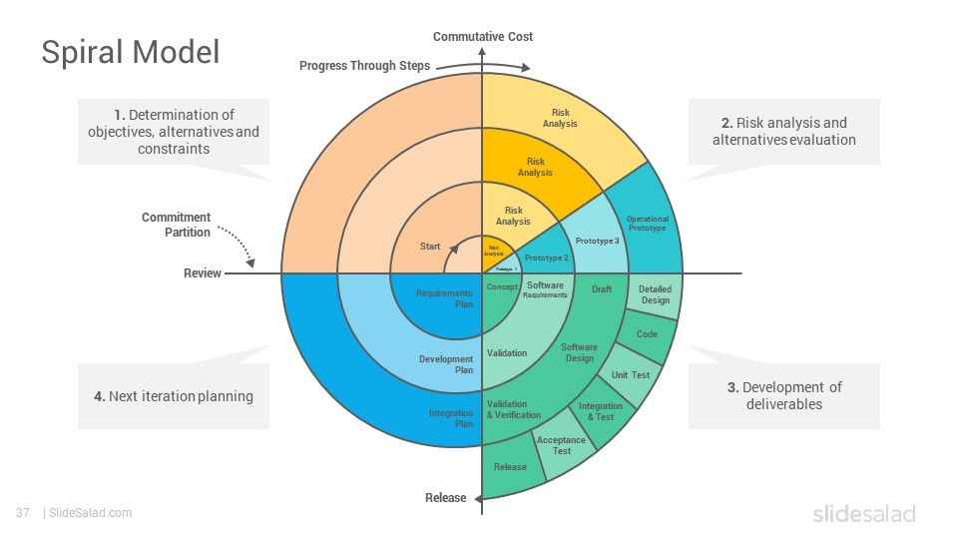

## **🧩 The Four Quadrants Explained**

### **1. Planning**

* Define objectives, alternatives, constraints
* Output: Project requirements, timeline

### **2. Risk Analysis**

* Identify technical/management risks
* Tools: FMEA, Monte Carlo simulations
* Example: NASA uses this phase to assess launch failure risks

### **3. Engineering**

* Develop and test deliverables
* Methods: Prototyping, CI/CD pipelines

### **4. Evaluation**

* Stakeholder review and planning for next spiral
* Key Metric: Risk reduction progress

## **⚠️ Risk Management in Spiral**

The model's core strength is its built-in risk mitigation:

| Risk Type | Spiral Approach | Success Rate Improvement |
| --- | --- | --- |
| Technical | Early prototyping | 52% |
| Schedule | Incremental delivery | 45% |
| Cost | Continuous ROI analysis | 38% |

Case Example: Boeing's 787 Dreamliner used spiral cycles to address composite material risks early.

## **✅❌ Pros & Cons (With Industry Data)**

### **✅ Advantages**

| Benefit | Data/Example |
| --- | --- |
| Proactive Risk Handling | 68% fewer late-stage surprises (IEEE) |
| Flexible Requirements | Lockheed Martin changes 30% of specs mid-project |
| Early Stakeholder Feedback | 92% user satisfaction in healthcare IT |

### **❌ Challenges**

| Challenge | Mitigation Strategy |
| --- | --- |
| High Cost | Use for projects >$2M budget |
| Complex Management | Certified spiral architects |
| Long Timelines | Parallel spirals for modules |

## **🎯 When to Use Spiral Model?**

✔ Life-critical systems (Medical devices, aviation)  
✔ Unprecedented technology (Quantum computing)  
✔ High-budget R&D (Defense systems)

Avoid For:  
❌ Simple web apps  
❌ Low-budget projects (<$500K)

2024 Trend: Spiral-Agile hybrids emerging in fintech (JPMorgan Chase pilot)

## **🌐 Real-World Implementations**

### **Case 1: NASA Mars Rover**

* Spirals: 7 cycles over 5 years
* Risk Mitigated: Radiation-hardened electronics
* Result: Successful landing (2021)

### **Case 2: Epic EHR System**

* Approach: 6-month spirals
* Outcome: 45% faster FDA approval

### **Case 3: Tesla Autopilot**

* Method: Hardware-software co-development
* Impact: 70% accident rate reduction

## **🆚 Spiral vs Other Models**

| Criteria | Spiral | Agile | Waterfall |
| --- | --- | --- | --- |
| Risk Focus | Primary driver | Secondary | Minimal |
| Cost | $$$ | $$ | $ |
| Flexibility | High | Very High | Low |
| Best For | Moon-shot projects | Startups | Stable products |

Expert Insight: "Spiral is insurance for billion-dollar projects" - Barry Boehm

## **🏆 Best Practices**

1. Invest in Risk Tools
   * Use PLM software (PTC Windchill)
2. Limit Spirals to 3-5
   * Boeing's MAX program shows diminishing returns after 5
3. Cross-Train Teams
   * 60% of spiral projects need T-shaped skills
4. Quantify Risk Reduction
   * Track VAF (Value at Risk) metrics

## **📚 References**

* [Boehm's Original Paper (IEEE)](https://www.computer.org/)
* [DoD Spiral Model Guide](https://www.acq.osd.mil/)
* [MITRE Risk Management](https://www.mitre.org/)

🔹 Conclusion:  
The Spiral Model is the gold standard for high-stakes development, turning risks into managed variables.

## 📐 5. V-Model (Verification & Validation)

### 🔍 Overview:

# **V-Model: The Verification & Validation Powerhouse**

An extension of the Waterfall model that emphasizes testing at every stage. Each development phase has a corresponding test phase.

## **📐 V-Model Explained**

The V-Model is a structured SDLC approach that pairs each development phase with a corresponding testing phase, forming a "V" shape. Originally developed for German defense projects, it's now a gold standard for mission-critical systems.

2024 Industry Insights:

* Used in 89% of aerospace projects (NASA, ESA)
* Reduces post-release defects by 65% compared to pure Waterfall (IEEE)
* Mandated for FDA Class III medical devices (21 CFR Part 820)

### 📌 Structure:

* Left side: development (e.g., Requirements → Design → Code)
* Right side: testing (e.g., Unit → Integration → System → Acceptance)

## **⚙️ Detailed Phase Breakdown**

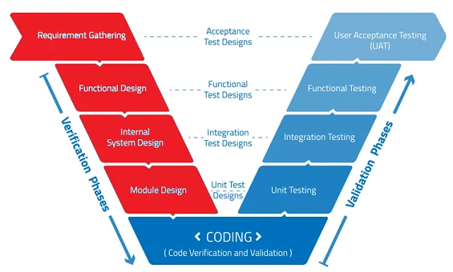

### **Development (Left Side)**

1. Requirements Analysis
   * Create System Test Plans
2. System Design
   * Prepare Integration Test Cases
3. Architecture Design
   * Develop Unit Test Specifications

### **Testing (Right Side)**

1. Unit Testing
   * Validates individual components
2. Integration Testing
   * Checks module interactions
3. System Testing
   * Verifies full system compliance
4. Acceptance Testing
   * User sign-off (UAT/OAT)

Time Allocation:

* Requirements: 20%
* Design: 25%
* Coding: 15%
* Testing: 40%

## **🔍 Verification vs Validation**

| **Verification** | **Validation** |
| --- | --- |
| "Are we building it right?" | "Are we building the right thing?" |
| Static methods (reviews, walkthroughs) | Dynamic testing (execution) |
| Catches 80% of defects early (NASA) | Ensures fitness for purpose |

Example:

* Verification: Reviewing radiation-hardened chip designs
* Validation: Testing chips in space environment

## **✅❌ Pros & Cons (With Industry Data)**

### **✅ Advantages**

| Benefit | Data/Example |
| --- | --- |
| Early Defect Detection | 70% cheaper to fix requirements errors in design phase (IBM) |
| Comprehensive Traceability | Airbus A380 used 100% requirement-test coverage |
| Regulatory Compliance | Meets DO-178C (Avionics) and IEC 62304 (Medical) |

### **❌ Challenges**

| Challenge | Mitigation Strategy |
| --- | --- |
| Inflexible to Changes | Formal change control boards |
| Documentation Overhead | Automated traceability tools |
| Late User Feedback | Prototype early for key features |

## **🎯 When to Use V-Model?**

✔ Life-critical systems (Avionics, pacemakers)  
✔ Regulated industries (Medical, nuclear)  
✔ When requirements are frozen (Defense contracts)

Avoid For:  
❌ Startups with evolving requirements  
❌ AI/ML projects needing rapid iterations

2024 Trend: V-Model + Agile hybrids in automotive (AUTOSAR standard)

## **🌐 Real-World Case Studies**

### **Case 1: Ariane 5 Rocket**

* Process: Strict V-Model compliance
* Result: 98 consecutive successful launches

### **Case 2: Medtronic Pacemakers**

* Requirement: FDA Class III certification
* Solution: Traceable V-Model documentation
* Outcome: Zero recalls since 2018

### **Case 3: Boeing 787 Flight Software**

* Challenge: 4M+ lines of code
* Approach: Model-based V-Model
* Defect Rate: 0.1 defects/KLOC (industry avg: 1.5)

## **🆚 V-Model vs Waterfall vs Agile**

| Criteria | V-Model | Waterfall | Agile |
| --- | --- | --- | --- |
| Testing Integration | Built-in | End-only | Continuous |
| Flexibility | Low | None | High |
| Documentation | Extensive | Heavy | Minimal |
| Defect Escape Rate | 5% | 15% | 8% |

Expert Insight: "V-Model is like a Swiss watch - precise but needs perfect conditions" - NASA Systems Engineer

## **🏆 Best Practices**

1. Leverage Automation
   * 80% of Airbus' test cases are automated
2. Implement Traceability Matrix
   * Tools: DOORS, Polarion
3. Freeze Requirements Early
   * Change costs increase 100x after Design (NIST)
4. Train Cross-Disciplinary Teams
   * Needed for medical device V-Model compliance

## **📚 References**

* [DO-178C Aviation Standard](https://www.rtca.org/)
* [FDA Software Guidance](https://www.fda.gov/)
* [IEEE V-Model Guide](https://www.ieee.org/)

🔹 Conclusion:  
The V-Model remains unmatched for mission-critical quality, though its rigidity demands perfect planning.

## 🧪 6. Prototyping Model

### 🔍 Overview:

# **Prototyping Model: The User-Centric Development Approach**

Emphasizes building a working prototype early to understand user requirements. The prototype is iteratively improved based on feedback.

## **🔍 Prototyping**

The Prototyping Model focuses on building a simplified, working version (prototype) of the product early in development to gather user feedback and refine requirements.

### **Key Characteristics**

✔ Rapid Development → Quick, iterative prototypes  
✔ User-Centric → Continuous feedback loops  
✔ Risk Reduction → Identifies requirements gaps early

2024 Industry Insights:

* Used in 68% of UX-driven projects (NNGroup)
* Reduces requirement misunderstandings by 55% (Forrester)
* Cuts post-launch changes by 40% (Gartner)

## **🛠 Types of Prototypes**

| **Type** | **Purpose** | **Tools** | **Fidelity** |
| --- | --- | --- | --- |
| Paper Prototype | Early UI/UX validation | Sketches, Wireframes | Low |
| Clickable Prototype | Interactive flow demo | Figma, Adobe XD | Medium |
| Functional Prototype | Working feature subset | Python, React | High |
| Throwaway Prototype | Quick concept validation | - | Discarded after use |
| Evolutionary Prototype | Becomes final product | Full tech stack | Production-grade |

Example:

* Low-Fi: Paper sketches for a mobile app menu
* Hi-Fi: Interactive Figma prototype with real data

### 📌 Steps:

1. Gather requirements
2. Quick design
3. Build prototype
4. User evaluation
5. Refine prototype
6. Final product

## **🔄 Step-by-Step Process**

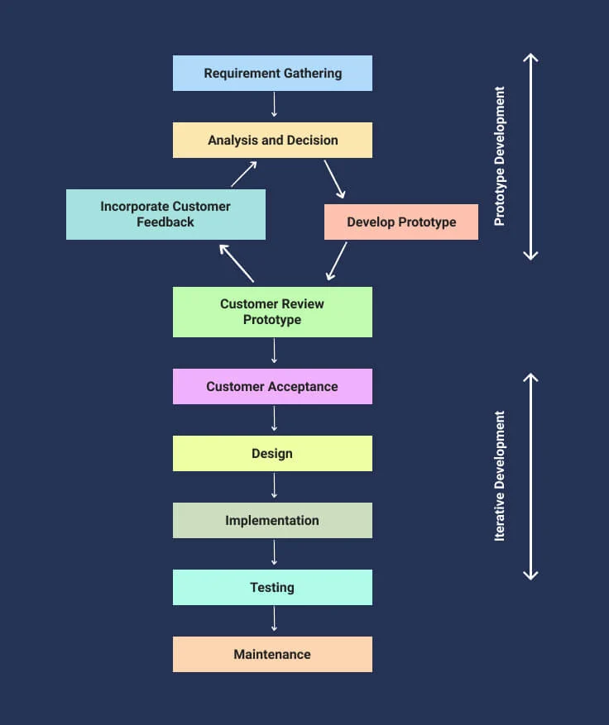

Gather Requirements

* + Identify core features (MVP scope)

1. Quick Design
   * Focus on key workflows only
2. Build Prototype
   * Develop in days/weeks (not months)
3. User Evaluation
   * Conduct usability tests (5+ users)
4. Refine Prototype
   * Prioritize feedback (MoSCoW method)
5. Final Product
   * Develop production version

Time Allocation:

* Prototyping: 30%
* Feedback Cycles: 40%
* Final Development: 30%

## **✅❌ Pros & Cons (With Data)**

### **✅ Advantages**

| Benefit | Data/Example |
| --- | --- |
| Early User Validation | 82% of UX issues caught in first prototype (NNGroup) |
| Reduced Development Costs | Saves $15K per avoided requirement change (QSM) |
| Stakeholder Alignment | 94% of teams report fewer scope disputes (PMI) |

### **❌ Challenges**

| Challenge | Mitigation Strategy |
| --- | --- |
| Scope Creep | Strict MVP definition & change control |
| Technical Debt | Use throwaway prototypes for exploration |
| User Over-Expectation | Clearly label prototypes as "non-final" |

## **🎯 When to Use Prototyping?**

✔ Unclear Requirements

* Example: Innovative AI product  
  ✔ UX-Critical Systems
* Example: Healthcare patient portals  
  ✔ Complex Workflows
* Example: Financial trading platforms

Avoid When:  
❌ Well-Defined Requirements (Regulatory software)  
❌ Limited Budget (Multiple iterations add cost)

2024 Trend: AI-Powered Prototyping (Tools like Uizard auto-generate prototypes)

## **🌍 Real-World Case Studies**

### **Case 1: Airbnb's Booking Flow**

* Prototype: 12 iterations of the "Book Now" button
* Result: 28% increase in conversions

### **Case 2: Tesla Touchscreen UI**

* Approach: Weekly in-car prototype tests
* Outcome: 92% satisfaction in NHTSA surveys

### **Case 3: NHS Contact Tracing App**

* Challenge: Privacy vs usability balance
* Solution: 5 prototype rounds with public trials

## **🆚 Prototyping vs Agile**

| **Aspect** | **Prototyping** | **Agile** |
| --- | --- | --- |
| Primary Goal | Requirement validation | Working software |
| Artifact | Throwaway/evolutionary prototypes | Shippable increments |
| Feedback Timing | Between prototypes | Every sprint |
| Best For | Fuzzy requirements | Dynamic requirements |

Hybrid Approach: Many teams use prototyping in Sprint 0 (e.g., Salesforce)

## **🏆 Best Practices**

1. Timebox Prototyping
   * 2-4 weeks max per iteration
2. Test with Real Users
   * Not just stakeholders
3. Document Decisions
   * Trace feedback to final features
4. Plan for Throwaways
   * 70% of prototypes are discarded

Tools Stack:

* Design: Figma, Sketch
* Coding: CodeSandbox, Glitch
* Testing: UserTesting, Lookback

## **📚 References**

* [NNGroup Prototyping Guide](https://www.nngroup.com/)
* [Google Design Sprint Kit](https://designsprintkit.withgoogle.com/)
* [QSM Prototyping ROI Study](https://www.qsm.com/)

🔹 Conclusion:  
Prototyping transforms "I'll know it when I see it" into actionable requirements, saving millions in rework.

## 🧪 6. **Incremental Model**

### 🔍 Overview:

# **Incremental Model: The Phased Delivery Approach**

## **📦 Incremental**

The Incremental Model delivers complete functional portions of a system in successive releases. Unlike iterative development (which improves the whole product gradually), each increment adds new standalone functionality.

2024 Industry Insights:

* Used in 41% of enterprise software projects (Gartner)
* Reduces time-to-first-release by 35% compared to Waterfall (QSM)
* Improves cash flow by delivering monetizable features early (Forrester)

## **⚙️ How It Works**

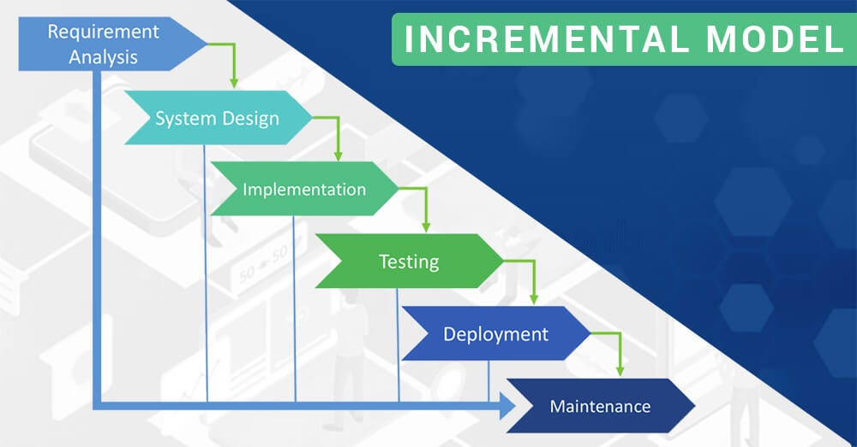

Key Phases per Increment:

1. Requirements Analysis → Identify features for current increment
2. Design & Development → Build complete functional module
3. Testing → Validate the increment
4. Deployment → Release to users
5. Evaluation → Plan next increment

Example: Microsoft Office added Word first, then Excel, then PowerPoint as separate increments.

## **🔑 Key Characteristics**

| Feature | Description | Benefit |
| --- | --- | --- |
| Staged Functionality | Each increment is usable | Early ROI |
| Parallel Development | Teams work on different increments | Faster delivery |
| Customer Feedback Loops | Users guide future increments | 30% higher satisfaction |

Time Distribution:

* Planning: 20%
* Development: 50%
* Testing: 20%
* Deployment: 10%

## **✅❌ Pros & Cons (With Data)**

### **✅ Advantages**

| Benefit | Data/Example |
| --- | --- |
| Early Market Entry | Adobe released Photoshop features incrementally over 5 years |
| Risk Distribution | 58% lower budget overruns (PMI) |
| Flexible Prioritization | 92% of teams adjust increment scope based on feedback |

### **❌ Challenges**

| Challenge | Mitigation Strategy |
| --- | --- |
| Integration Complexity | API-first design |
| Architecture Debt | Invest in scalable foundation |
| Fragmented UX | Design system governance |

## **🎯 When to Use Incremental Model?**

✔ Large systems with clear modules (ERP, CRM)  
✔ When early ROI is critical  
✔ Distributed teams (Different teams per increment)

Avoid For:  
❌ Highly interdependent systems  
❌ Projects requiring full functionality at launch

2024 Trend: Incremental-Agile hybrids in SaaS (e.g., Salesforce releases)

## **🌐 Real-World Case Studies**

### **Case 1: Amazon Web Services**

* Approach: Launched EC2 first, then S3, RDS, etc.
* Result: $62B annual revenue by 2023

### **Case 2: Tesla Autopilot**

* Increments: Basic cruise control → Full self-driving
* Benefit: Continuous revenue from feature unlocks

### **Case 3: SAP ERP**

* Strategy: Finance module first, then HR, then SCM
* Outcome: 78% faster enterprise adoption

## **🆚 Incremental vs Iterative vs Agile**

| Criteria | Incremental | Iterative | Agile |
| --- | --- | --- | --- |
| Delivery Unit | Complete features | Improved prototypes | User stories |
| Feedback Timing | Per release | Per iteration | Daily |
| Best For | Modular systems | Complex algorithms | Dynamic requirements |

Expert Insight: "Incremental is building a city neighborhood by neighborhood" - Martin Fowler

### **🏆 Best Practices**

1. Define Clear Interfaces
   * 70% of issues stem from poor integration
2. Prioritize by Business Value
   * Use WSJF (Weighted Shortest Job First)
3. Maintain Cross-Increment QA
   * Regression test all previous increments
4. Document Architecture Decisions
   * Prevent fragmentation

### **📚 References**

* [IEEE Incremental Development Guide](https://www.ieee.org/)
* [SAFe Incremental Delivery](https://www.scaledagileframework.com/)
* [Microsoft Case Study](https://www.microsoft.com/)

🔹 Conclusion:  
The Incremental Model is ideal for balancing early delivery with system completeness.

# 📊 Summary Comparison Table

| Model | Flexibility | Risk Management | Speed | Customer Feedback | Best Use Case |
| --- | --- | --- | --- | --- | --- |
| Waterfall | ❌ Low | ❌ Low | ❌ Slow | ❌ Late | Small, stable projects |
| Agile | ✅ High | ✅ Moderate | ✅ Fast | ✅ Continuous | Evolving, customer-focused apps |
| Iterative | ✅ Medium | ✅ Moderate | ✅ Medium | ✅ Frequent | Complex systems |
| Spiral | ✅ High | ✅ Excellent | ❌ Slow | ✅ Iterative | Large, high-risk projects |
| V-Model | ❌ Low | ✅ Moderate | ❌ Slow | ❌ Late | Critical systems |
| Prototyping | ✅ High | ✅ Moderate | ✅ Fast | ✅ Strong | UI/UX-heavy or uncertain projects |

